Amber Lynch
ANTH 028
Zuckerman
Midterm Project: Speech as Social Action
One of my favorite TV shows is The Office because of how the humor is delivered. There is no laugh track or acknowledgment that the events going on are abnormal except for the character Jim. The characters are given opportunities to explain their thoughts about events in an interview with the camera directly, but the majority of the content is a documentary-style look into a “normal” office. One of the funniest scenes occurs in Season 3 Episode 21, where a usually laid back and down to earth Jim impersonates the notoriously deadpan, strict, and intense Dwight. Dwight’s style of speech is is a big contributor to what makes the show funny because it is very distant from how one would expect a coworker to talk. A character that is relaxed and relatable imitating one who is the polar opposite highlights just how absurd Dwight’s personality and actions are. Despite Dwight’s apparent lack of social skills and intense demeanor, he has somewhat of a friendship with Jim through their pranks and lighthearted interactions.
The scene starts with Jim entering the office wearing a shirt of the same color as Dwight, his hair flat and bangs pushed down, and his physicality is significantly altered from what is usually is. He walks with purpose and tension, and gets his materials ready for work in a intensional and direct fashion. The conversation that follows not only is funny to the audience because of Jim’s actions subverting expectations, but also Dwight’s response to being imitated. Below is a chart that demonstrates how Jim subverted Dwight’s expectations and how Dwight responds.
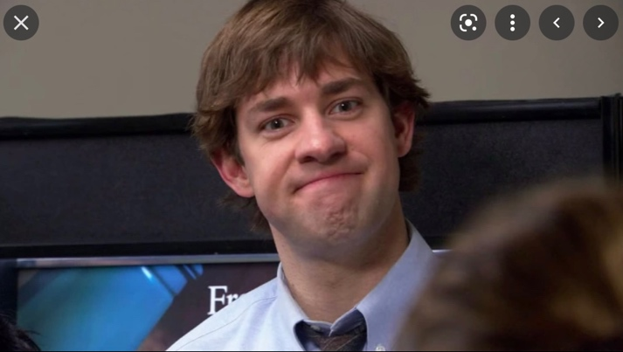  An example of Jim’s typical caliber | 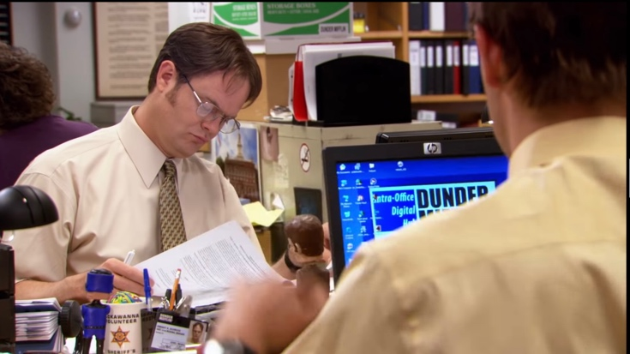  Unassuming Dwight starting his day
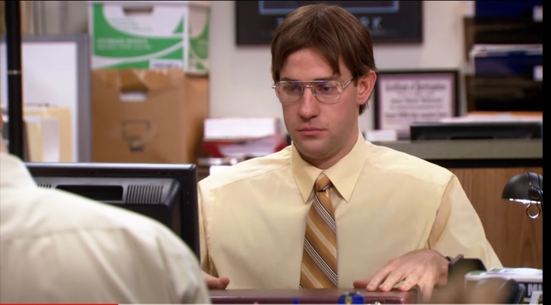  “It’s kinda blurry” (puts on glasses) “That’s better” | 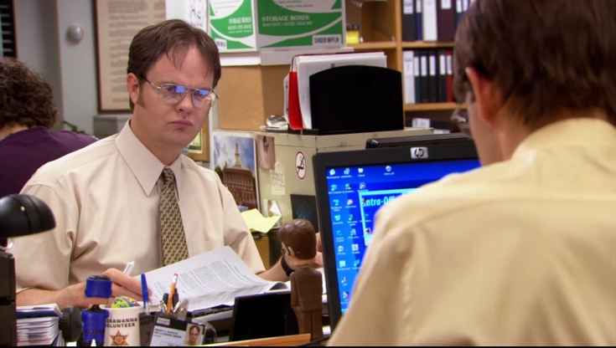  Dwight directs his attention to Jim

As seen here, Jim uses the unprompted phrase “It’s kinda blurry” to call attention to the fact that he is putting on glasses, which is abnormal for his character. This phrase serves a social action beyond just the words used in the utterance, because he is not appearing to directly address anyone or provide information. Rather, he is further developing his social relationship with Dwight by calling attention to his harmless prank of dressing up as him. As explained by Goffman on page 137 in the Chapter “Footing,” the participation status is the relationship of the speaker to the utterance, and the participation framework is the group of individuals involved in the interaction. Goffman argues that these terms “can be employed when the point of reference is shifted from a given particular speaker to some- thing wider: all the activity in the situation itself.”This idea is especially relevant in the above interaction, as the utterance “it’s kinda blurry” serves as an attempt for Jim to indicate to Dwight that something is different about Jim today, and he is trying to get Dwight to pay attention to Jim’s odd behavior. Jim’s participation status is shifted from the speaker to the object of the interaction, as Dwight’s non-verbal cue of looking up from his desk indicates his focus being directed at Jim. Because Jim was able to get Dwight’s attention with this utterance, it clearly was meant to serve as a social action beyond just informing Dwight that his vision was blurry. He used the change in footing to draw Dwight’s attention to his prank.
The interaction continues as Jim further adopts Dwight’s mannerisms and speech pattern. A common occurrence in the show is Dwight starting his informative utterances with “Fact.” Jim adopts this to challenge Dwight’s knowledge of bears and beets, which has been previously thoroughly established. Jim then interrupts him, listing things that seemingly have no relation, but have a common theme of things Dwight likes. Below is a chart representing this interaction and Dwight’s response.
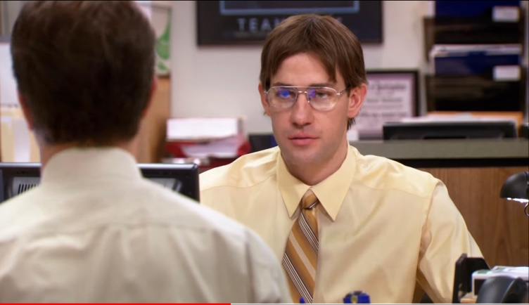  “FACT. Bears eat beets.” | 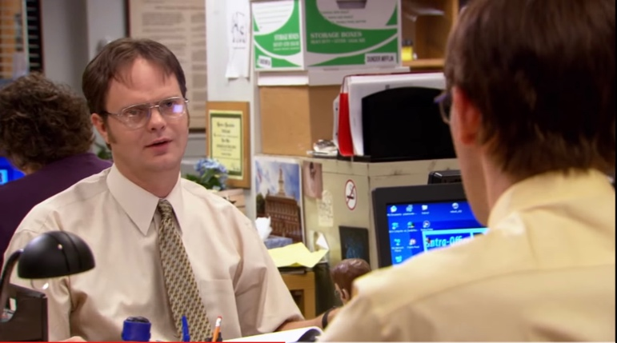  *scoff* (rolls eyes)
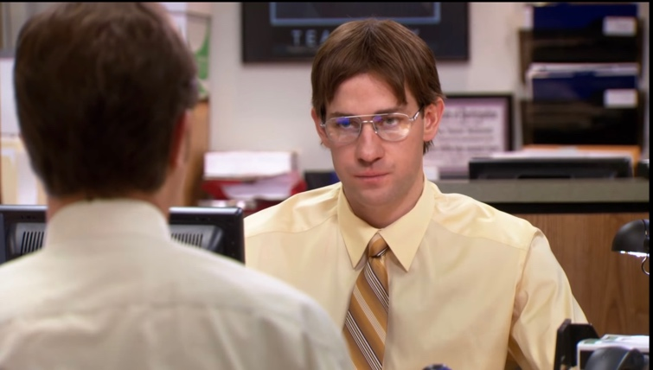  “Bears. Beets. Battlestar Galactica” | 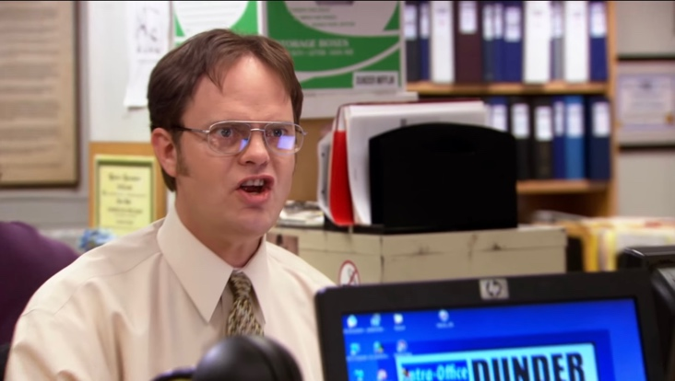  “WHAT IS GOING ON? WHAT ARE YOU DOING”

The utterance “bears eat beets” elicits a relatively passive response as Dwight scoffs and prepares to defend himself. The background context for this choice of utterance to provoke a response in Dwight is that his family owns a beet farm, and he is very knowledgeable about bears. Dwight likely has a way to disprove Jim’s claim, and is ready to share it. However, he is not given the chance when Jim, again unprompted, lists “Bears. Beets. Battlestar Galactica”. When this utterance is analyzed through the perspective of Grice, this utterance would violate his maxim of relevance. In “Logic and Conversation,” Grice claims that interlocutors assume four maxims in conversation, one of them being that the hearer assumes the speaker’s utterance is relevant to the topic of conversation. If a maxim is not being followed, it leads to implicatures, or a deeper meaning of the utterance not being explicitly stated. In this example, Dwight assumes that Jim’s utterance will be relevant, but at first glance, bears, beets, and Battlestar Galactica seem to have no relation to each other. This drives Dwight to think further, and draw an implicature to what Jim might be indicating at a deeper level beyond explicit speech. Dwight suddenly draws the conclusion that these three things to in fact have relevance because they share a common theme: Things that he likes. Combined with all the previous clues, such as Jim’s style of speech, dress, and the unprompted statement about his vision, Dwight realizes he is being imitated.
Dwight’s response again shifts the footing of conversation to the fact he is being impersonated rather than the behavioral patterns of bears. He asks Jim what he is doing, indicating his focus is no longer on the topic that Jim was talking about, and rather what Jim might be implicating with his action of speech. Dwight has realized that Jim’s utterances in this interaction were serving a social action beyond just the words spoken, which is to annoy him. The dramatic irony in the audience as they know what Jim is doing immediately and watch Dwight figure it out results in a scene that is incredibly hilarious. Dwight’s usual demeanor is serious and focused on his work, so seeing him get very upset over a small harmless interaction subverts the audience’s expectations and adds to the humor and entertainment of the show.
As I first watched this scene several years ago, I remember laughing out loud. It is probably one of my favorite scenes in television, and I had always figured it was because of the clever writers. However, with a deeper analysis of why in fact it is so funny to me led me to realize that it is not only the writing of the show, but the actor’s non-verbal cues and established context that cause the audience to pick up on the goals of the characters. A close analysis of the character’s reactions, both verbal and non-verbal, through the perspective of language philosophers results in concrete example of how speech is used to serve a social purpose beyond just informing or describing.

