LING 178- Sociolinguistics
Ben Sienicki
Capstone Project Description

As a capstone, the research project provides an opportunity to survey course themes in retrospect and then dive deeply into one that grabs your attention the most. To narrow the scope of your project, you’ll start from a single theme we’ve covered thus far (see thematic bullet points in syllabus) and build a specific research question within that theme. The more you can narrow your scope at the outset, the less messy your research process will be, so I suggest that you begin with something very specific and then generalize as needed. For example, within the theme of social class and language, you could ask, “How does the process of ‘borrowing prestige’ lead to hypercorrection in Present-day English (PdE) pronouns?” and then later add secondary questions as needed, like “How does a speaker’s education level impact the process of ‘borrowing prestige’ in the usage of PdE pronouns?”
An important feature of this assignment is that it’s question-driven, so you don’t want to be diving into the ocean of Google Scholar or CATQuest without first knowing what, in particular, you’re trying to find out. If you have a hard time discovering existing research that addresses your research question, you can ask me for help—it may just be an issue of getting the right search words or data sources—and if all else fails, you can adjust your question as you go, fitting it to the research that’s at hand. In class in the upcoming weeks, we will brainstorm a variety of possible topics and research questions, in case you have a hard time coming up with something to explore. A central motivation for you, meanwhile, should be to find a topic/question that’s truly interesting to you, not just one you think would be “easy” to research. Your curiosity will sustain you in this project more than anything, and that energy will almost certainly carry over into the report and slide show that you’ll be constructing.
You will need to accomplish two tasks in the research project report: (1) tell the story of your research process, including how your research questions evolved as you read sources or collected data, and (2) provide an informed answer to your research question(s) based on course texts, scholarly works you find online or at the library, and original corpus-based/observational data. The report should be 5-6 pages, double-spaced, typed. You will also prepare a brief ppt or G-Slides presentation (4-6 slides in length) as a summary/overview of your project, to be shared with the class Weeks 15-16.
As you can see, this project will primarily be based on course texts and other materials you find on Google Scholar or CATQuest, but wherever possible (depending on your topic and question), I’d like you to add supplemental data from (a) original corpus-based investigations of the MICASE, SLAAP, or CORAAL, or (b) observational data that you’ve collected (e.g. observing/documenting discourse in a public space or recording friends/others in interview-format). Inclusion of original data will be a secondary component of the assignment, in other words, and should color your report and slide show.

Amber Lynch
LING 178 - Sociolinguistics
University of Vermont
Capstone Paper- Gender and Cursing

So far in the class, we have looked at different ways people conform to social norms through attaining different levels of overt or covert prestige. Different experiences and identities form one intersectional identity, influencing how people can fit into different parts of society. People use language to push one aspect of their identity more than others or avoid certain elements of language to make themselves more distant from another identity. However, something exciting that we did not cover in class was what types of speech were not socially acceptable yet continue to be used in causal conversation and therefore are maintained in the language. Everyone who has graduated from elementary school knows specific words not to say, but I was never explicitly taught why these words were so problematic. I figured this project would be a great chance to explore some patterns around swearing and be a great jumping-off point for future research on this topic.

My first step in the process was narrowing down precisely what question I wanted to answer with this project. After I decided I generally wanted to work with swearing, I listened carefully to informal discourse and notes contexts in which people swore and who was swearing with which words. After a few days of anecdotal research, I noticed that the most significant observation I was making was how differently swearing occurred between people of different genders. Since the people I was observing were generally all people of the same race, education level, and age, it made the most sense logistically to control for gender. My research questions have been narrowed down to how gender influences the frequency of swearing, the variety of lexical items used, and why people swear. These questions were relatively narrow and quantifiable, which was another goal of mine. I wanted to be able to look at numerical data instead of anecdotal interviews, and I figured a goal of answering these questions was relatively attainable with the time and resources I had.
This allowed me to start researching the existing literature on my new, narrowed topic. The first article I found was called Gender and Swearing: A Community Practice by Karyn Stapleton. This article builds on the idea of studying language through the Communities of Practice perspective pioneered by Eckert and McConnell-Ginet. According to the article, women tend to swear less than men because they are more susceptible to societal pressures to conform to notions of femininity, such as being “deferent, polite, nurturing, and oriented towards the needs/feelings of others.” Swearing is traditionally seen as a form of aggression, a “masculine” trait. Stapleton cites a study by De Klerk, where it was found that women’s use of swearing is evaluated more negatively than the same use by men. The most relevant goal of Stapleton’s study was to look at a specific community of practice and determine differences in the perception and use of swearing among men and women.

Stapleton’s methods of study start with defining a specific community of practice. In her case, she interviewed a group of 30 students who were friends and routinely went out for drinks together in a small urban town. Fifteen of the participants identified as male, and fifteen identified as female. They were interviewed one-on-one and asked several questions about their reasons for swearing, perceptions of specific words, and their perceptions of people of the opposite gender swearing. The part of the study that interested me the most was how they were given a list of words and asked whether they used them and if they would find it obscene if another person in the group said those words. This was a pivotal point in my research because I figured I could attempt to replicate these findings among my community of practice and compare the data.

This study was conducted in Ireland, and the specific words used in the study are clearly Irish dialectal slang. To truly compare the findings, I would need to change some of the words, so they more accurately represent common words among American college students. For example, instead of “fanny” to refer to a female’s sexual anatomy, I used “pussy” instead. I know this term is not just used to refer to a part of female anatomy but is occasionally used as an insult as well. I am not familiar with Irish slang, so I am not entirely sure if this term carries the same connotation in Irish English. While the word officially refers to the same thing, it might not always be used in the same way as its American counterpart. This is a clear limitation in my survey. If I were to continue this research, I would collect more detailed information about the uses of these words in Ireland to ensure they can be compared accurately. For other words, such as “arse,” I was aware of the American counterpart “ass,” and the issue of connotations differing across dialects was not as prevalent. There were some words with no American equivalent, which I removed, and some that are used in both places, such as “fuck.” I wanted to ensure I had an equivalent number of words, so I figured replacing them with words with the same relative level of intensity was the most effective way to compare the findings.

I created a Google Form with a list of sixteen common swear words I have heard my friends say and seen on social media and asked the participants to list words out of the bank provided that they would use and the words they would be offended by if someone else used them. Next, I posted a link to the survey on my Snapchat story and invited anyone who saw the story to complete the survey. I also sent a link to the survey to my group of friends and asked them to send it to their friends. After compiling some initial data, I presented my project proposal to the LING 178 class, and the people in the class also filled out the survey. In total, I got 84 responses from students at various colleges. While this is not a specific Community of Practice in the way Eckert and McConnell-Ginet would define it, I figured this data was still relevant because the sample was a group of people with the same educational level and age and who live in the same country. Forty-five of the respondents identified as male, thirty-seven identified as female, and two identified as “other.”
A significant limitation of Stapleton’s study was the lack of information regarding people who do not identify with the two gender categories she creates and a general lack of acknowledgment of this oversight. While the article was written in 2003, people still identified as non-binary, and it would have been much more inclusive of acknowledging that as a limitation in the study. However, I made sure to include an option for people who do not conform to the gender binary to participate in the survey. Since only two respondents identified as “other,” it is not nearly representative of the non-binary community, but this is a potential jumping-off point if I wanted to continue researching this topic in the future. I did not find any sources looking at non-binary patterns in obscene language use, and with more people feeling comfortable enough to be transparent about their gender identity in today’s society, there is definitely room and relevance for this research to be carried out in the future.

In my survey, the two non-binary participants agreed on their use and perception of swearing. Both would not say any of the words and would find it offensive if they heard them, so there is not any indication, according to this data, that the words themselves differ in how they are perceived. Instead, this data suggests that the fact that a speaker is swearing at all is offensive to these individuals. Because there is no variation between words, I will not include the non-binary responses in my explanation of the results when cross comparing the proportion of respondents who were offended by certain words. This is a limitation of not having enough participants who identify as non-binary. However, this is not to ignore the responses of these participants because of their gender identity, and further research is needed to ensure an accurate representation.

When looking at the female and male participants’ responses, several patterns emerge. Firstly, that 15 out of the 16 words I provided would be used by and would not offend the majority of female respondents. More surprisingly, all words would be used by and would not offend the majority of male respondents. As seen in the chart below, there is a significant difference between words that are offensive to say and hear by the highest proportion of respondents of both genders and words that are not. However, there is a higher proportion of females who would be offended by hearing and would not say these words than males. The word deemed most offensive was “cunt,” with 60% of the female respondents reporting that they would not say or like to hear this. This was also the word men deemed most offensive to say or hear, with about 30% for each question. The next most offensive words for females to hear are “pussy” and “tits,” with at least 30% of female respondents saying they would be offended by saying or hearing these words. A slightly higher percentage of females would not say “prick,” “pussy,” or “cum.” For male respondents, the most offensive words were the same, with “pussy” and “tits” being the next most offensive to say relative to the other proportions, but only 20-30% of males would find these words offensive.. There were no standout words other than “cunt” and "pussy" that males would be offended by hearing. These trends can be seen on the chart below.
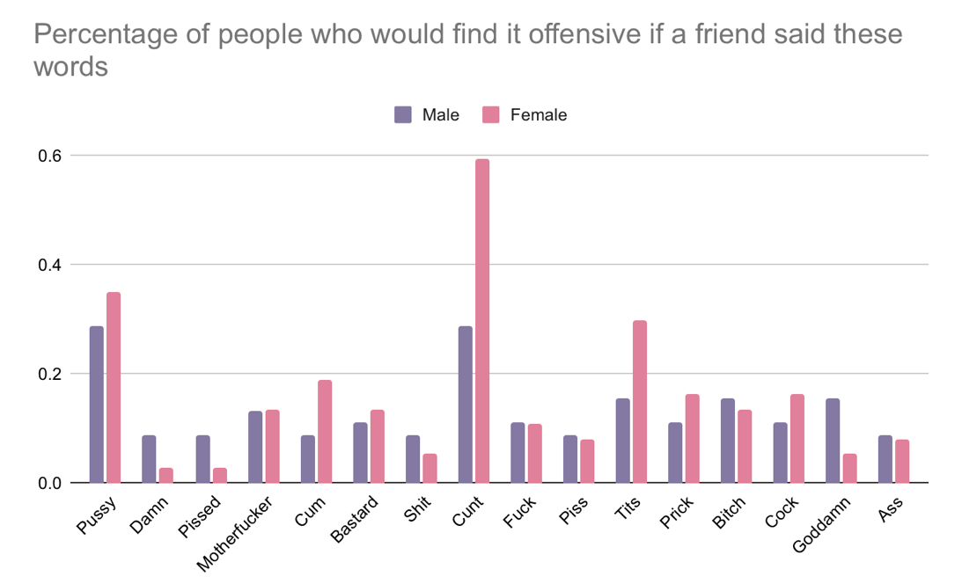
Something interesting that I noticed after analyzing the data was that the words found most offensive were words referring to parts of female anatomy. I have heard these words used as insults more often than the other terms, which raises the question of why words about female anatomy are the most offensive. The male counterparts, like “dick” or “cum” for example, were not seen as nearly as offensive. A student brought up this topic in class as I was presenting the proposal for this project, and he mentioned the fact that the word “pussy” when referring to the part of the body does not have the same negative connotation as when it is used as an insult towards a guy. Calling a guy a “pussy” indicates that they are weak or a wimp, which threatens their traditional notion of masculinity. Women are not usually called a “pussy,” as being weak is not a threat to the traditional notion of femininity as defined by Stapleton above.
Talking to friends of both genders about the survey results indicated that a significant limitation that could have affected the data was that the question of whether they would be offended by hearing the word used was not straightforward. I did not specify whether the word was used as a derogatory term towards the participant or if they just heard it generally in conversation. If I were to continue pursuing this research, I would ask more specific questions
about the context and interview the participants individually about their perspectives behind their responses.
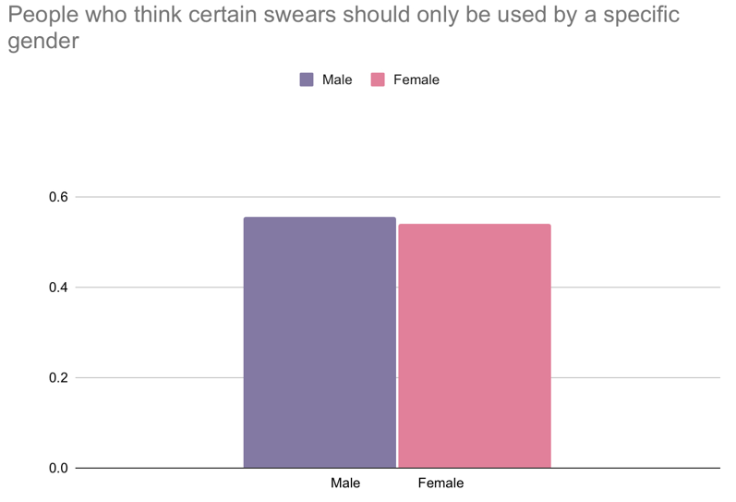
Another question I asked in the survey was whether the participants thought certain words should only be used by certain genders. This means that a feminine word, such as “cunt” should only be used by women. I was expecting more women to have this view, as women are clearly more offended by the use of feminine terms, and the participants in Stapleton’s study represent this view. However, while very close, a slightly higher proportion of males thought this should be the case, as seen in the chart below. This is another topic I would love to explore in the future, as I think the reasoning behind the responses would clarify some crucial perspectives. I wonder if there are specific words that participants think apply to this more than others and if the words differ by gender. Both non-binary participants responded “no” to this question.
One last limitation that my friends brought to my attention was that I chose the words worth asking about. My inspiration for the terms came from Stapleton’s study, but they might not represent what American college students consider common curse words. It would be interesting if I continued this research to survey participants regarding which swear words they use without prompting them with a list. I did not include racial, ethnic, or homophobic slurs as they are inherently problematic in casual use, and Stapleton’s study did not include them. However, it would be interesting to look at perceptions of the use of these words by both people they are referring to and those not in that group.
Overall, this was a relatively informal study with several limitations. However, the findings support a general trend of feminine words being the most offensive and least likely to be used. This traces back to Stapleton’s idea of femininity being seen as inferior to males in society, and using feminine words carrying more weight than male words. Stapleton states that “expletives carry strong connotations of lower socioeconomic groupings” in their use and the meanings of the words themselves. It, unfortunately, makes sense that feminine terms are more offensive and less used by women because of the misogynistic structure of today’s society. While the participants in this study only represent one demographic, a replication of this study with a broader selection of participants will likely represent the same trends. Gender is clearly articulated through language, and what is not deemed socially acceptable represents the same trends of inequality and sexism we have already seen.

References:
de Klerk, V. (1997). The role of expletives in the construction of masculinity, in S. Johnson & U.H. Meinhof (Eds.), Language and Masculinity (pp. 144-158). Oxford: Blackwell.
Eckert, P. & McConnell-Ginet, S. (1995). Constructing meaning, constructing selves: Snapshots of language, gender, and class from Belten High. In K. Hall & M. Bucholtz (Eds.), Gender articulated: Language and the socially constructed self (pp. 469-507). London: Routledge.
Stapleton, K. (2003). Gender and swearing: a community practice *. Women and Language, 26(2), 22+. https://link.gale.com/apps/doc/A112359435/AONE?u=googlescholar&sid=bookmark-AONE&xid=ffe86fba

