"Why do we work so hard?": Electric Cars, Combative Advertising, and a Neoliberal Critique of American Exceptionalism
Amber Lynch
LING 3210 Final Paper

1. INTRODUCTION
In a neoliberal capitalist system, consumers make economic decisions based on their perception of how such a decision might improve their lives. A profit-driven company is therefore encouraged to demonstrate how and why purchasing their product will benefit that consumer. The importance and effectiveness of advertising as an explicit way to send this message to the consumer is seen constantly in public places, entertainment, and online. Not only must companies stand out to the consumer by making an advertisement, but the oversaturation of advertisements adds another level of pressure to make these advertisements engaging and memorable. Some companies use and transform elements of a competitor's advertisement to encourage comparison and show superiority. This multimodal discourse analysis considers one such instance. In 2014, Ford released a commercial for their new hybrid coupe, the CMAX Energi, that directly challenged the rhetoric used in a Cadillac ad for the ELR, a luxury electric coupe. Instead of including specific information about the product in these ads, Cadillac and Ford strategically use semiotic strategies to debate nuances in consumerist neoliberal theories. Each suggests an ideology that empowers individuals to improve their circumstances through their uniquely American drive to work hard, ultimately offering conflicting perspectives on the role of consumption.
2. LITERATURE REVIEW
2.1 Neoliberalism
The theory of neoliberalism has had a complicated and nuanced history. The term was first used in 1898 to propose that the freedom for an individual to pursue their interests combined with the deregulation of corporations would create a world where "The law of supply and demand will bring about the maximum of utility for both the individual and society," unlike what was previously seen in laissez-faire capitalism (Gide, 1898). In contrast to classical liberalism, neoliberalism is built on the idea that a "good" society will never occur naturally and can only result from a collective effort. The ideal participant in such a system is known as the homo economicus, one who reliably and consistently calculates their economic decisions to serve their interests (Ganti, 2014).
As implementing neoliberalism manifested differently across many places, the term began to take on additional meanings. Neoliberalism grew from an ideology to a model for public policy, resulting in an economic mindset that became intertwined with culture. In the US, neoliberalism creates an ideological effort to "portray consumption, competition, and consumer sovereignty as integral to the definition of the American way of life" (Scott, 2018). The ability of an individual to consume depends on their ability to work. American neoliberalism therefore promotes an environment where education and the resulting corporate landscape encourage discourse around skills, conceptualizing a person as just a "bundle of skills" and valuing them based on what they can exchange with the labor market (Ganti, 2014). Workers are then expected to work long hours to create the necessary capital. This oppressive system is antithetical to the ideas of American Exceptionalism, creating an ideological paradox. To solve this, governing strategies construct the uniquely American conceptualization of freedom as being expressed through consumption rather than action. For that to work, the system must profit producers and benefit consumers. Brands must communicate the utility and value of their products to consumers through advertising (Castro, 2015). However, an investigation of how companies use specific rhetoric in advertisements to encourage the uniquely American idea of consumption as a means to freedom has yet to be conducted.

2.2 Combative Advertising
Counterculture movements have used parody as a method to promote anti-consumerist messages and fight oppressive aspects of the neoliberal system. A brand imitating a specific advertisement from another brand, described as combative advertising (Attar, 2015), to sell a similar product serves to entertain the audience while at the same time attempting to tarnish a competitor's image. However, the success of a brand parody hinges on how familiar that audience is with the original advertisement. Jean (2011) analyzes how effectively a 2006 Sandisk campaign parodying the Apple iPod changed participants' perceptions of Apple. Sandisk borrowed the signature "i" prefix seen in the iPod, calling iPod users "iSheep" who need to leave the "iTatorship." While the participants found the idea of combative advertising humorous, participants were surprisingly more critical of Sandisk for making the parody than supporting their criticisms of Apple. Jean (2011) explains this by suggesting that Apple's greater size and influence than Sandisk results in strong consumer loyalty despite seeing criticism.
While Sandisk's ad offered criticism of the reputation and practices of Apple as a whole, they crucially did not suggest an alternative Sandisk product to replace the revolutionary iPod. Vehicles, however, are inherently defined by their ability to transport, something universal across any brand. Car advertisements must go beyond showing features that appear in most comparable cars from other brands and instead focus on distinguishing the brand as superior to other brands. For example, in 2009, Audi released a billboard in Santa Monica to promote their "entirely new Audi A4" with a white background behind an image of the car and the text "Your move, BMW." In response, BMW bought a neighboring billboard to display a parody of the ad, using a black background behind their comparable model and the text "Checkmate." Audi reacted with another billboard, using the black background and the text "Your pawn is no match for our king." Attar (2015) conducted a multimodal discourse analysis of these ads to explore the interplay between visual and verbal semiotic modes to construct meaning for viewers. This analysis suggests that the marketing teams made deliberate semiotic choices to convince customers of their superiority while belittling the other. A physical advertisement is inherently restricted to its place, limiting the potential number of viewers. Effective billboards use text scarcely for legibility since they are glanced at for only a few seconds. Television commercials, however, can quickly reach a broad audience and rely on combining dialogue, visuals, and sound to communicate a clear and detailed message to the consumer. Creating a commercial is expensive, and creating a commercial to critique another brand's commercial poses a risk to its image. A formal multimodal analysis of combative advertising in a commercial has yet to be done, with the potential to reveal how brands semiotically construct and deliver a message to consumers.

3. METHODOLOGY
In order to examine how Cadillac's and Ford's commercials perpetuate neoliberal discourse, a multimodal discourse analysis is conducted. As a specific form of critical discourse analysis, a multimodal approach allows for additional forms of semiotic data, such as pictures and symbols combined with language, to be considered appropriate data for analysis. Because language reflects reality in addition to constructing and reproducing how we experience the world, discourse analysis can reveal taken-for-granted assumptions in social, societal, political, and economic spheres using semiotic decisions (Golsorkhi et al., 2015). Comparing subtle semiotic choices between two commercials with the same structure can also provide insight into how Ford uses parody to critique Cadillac's construction of homo economicus. To do this, I have followed the framework described by Golsorkhi et al. (2015). Their methodology for critical discourse analysis consists of the following four parts:
1. Defining research questions that concern social and societal importance
2. Careful selection of a sample of text
3. Engagement in a close reading of the specific text
4. Elaboration on key findings and placing them in a wider context
The following analysis of multimodal discourse has been divided into the above sections.

4. DATA AND ANALYSIS
4.1 Defining research questions that concern social and societal importance
This analysis describes how multimodal semiotic communication in advertisements communicates a brand's stance on neoliberal ideologies. The following two questions are considered:
1. How do advertisements combine multiple modes of semiotic communication to demonstrate how members of a neoliberal society improve life through consumerism?
2. How do brands critique ideologies promoted by other brands through combative advertising (in the form of parody)?
Understanding the underlying ideologies perpetuated by advertisements allows consumers to form educated opinions of brands and make informed economic decisions. Identifying how these narratives manifest semiotically in media can give viewers a more nuanced perspective on the role of the individual in a neoliberal society.

4.2 Careful selection of a sample of text
One selected media for this analysis is Poolside, a one-minute television commercial for Cadillac's new electric coupe, the ELR. This text is analyzed in comparison to Upside, a parody commercial created by Ford to promote their comparable hybrid model, the CMAX Energi. The original Cadillac commercial first aired at the 2014 Olympics, reaching a broad audience and creating controversy among viewers (Symes, 2014). In response, Ford's criticism in the form of a shot-by-shot and line-by-line parody directly challenged Cadillac to add another perspective to the discussion. While both advertisements in their entirety are worthy of in-depth investigation, only the most relevant sections have been analyzed here, given the scope of this paper. Complete side-by-side transcripts can be found in the Appendix.

4.3 Engagement in a close reading of the specific text
Although the titles of these commercials are not explicitly presented to the viewer, a title can provide insight into the creator's expectations of how viewers construct meaning from the media. The title Poolside hints at the importance of the commercial's physical setting for its meaning. In contrast, Upside is said in the concluding line of the monologue (in both commercials), drawing attention to Ford's distinction between their and Cadillac's perspectives on why people should work hard.
The spokespeople for these advertisements are assumed to be speaking as themselves rather than playing a character. Cadillac hired actor Neal McDonough, known for performances in antagonistic roles. Ford worked with Pashon Murray, who co-founded the group Detroit Dirt to advocate for composting and the importance of sustainability. The demographics of these representatives might suggest the intended audience for these ads. Cadillac sees its ideal consumer relating to an upper-class middle-aged white man, while Ford seems to be speaking to a more diverse audience by featuring a younger Black woman.
While the camera angles and shots are identical between the commercials, the color temperature and saturation are drastically different. Cadillac made the footage warmer and oversaturated, suggesting a cozy and inviting atmosphere. Ford heavily cooled and desaturated the beginning shots but added more color as the product was shown. The world that initially feels dark, depressing, and distant becomes welcoming and enticing with the car's introduction.
Pairs of still frames and the corresponding language use are presented below, with Cadillac's Poolside on the left and Ford's Upside on the right.
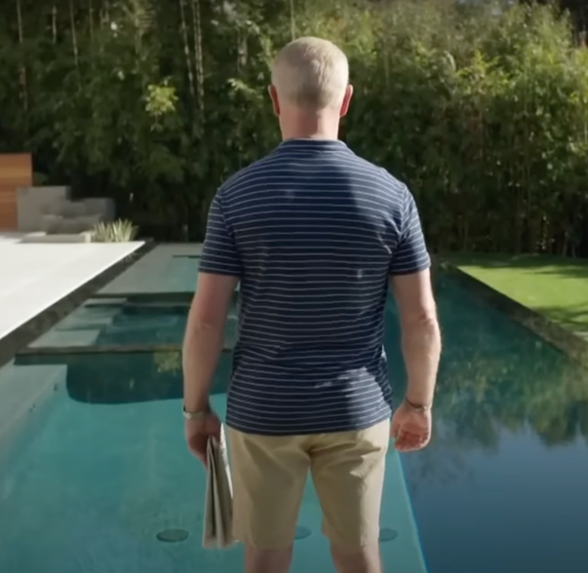 | 
"Why do we work so hard? For this? For stuff?" | "Why do I work so hard? For this? For dirt?"
Cadillac opens the commercial with a rhetorical question, challenging the idea that viewers only work to afford luxurious material possessions, like the pool and tidy landscaping shown in the shot, while suggesting there is another, more powerful motivation driving hard work. The use of "we," referring to Americans, indicates that McDonough and the collective audience share the same drive and incentives to work hard. In contrast, Ford's opening asks why an individual works hard without directly including the audience by using "I." The idea that Murray is working hard "for dirt" has a layered meaning, as is revealed later in the advertisement. The audience learns later she works to create literal dirt through composting, while "dirt" can also describe something with a low cost, like the phrase "dirt cheap." While she acknowledges the audience likely does not see the value in working for the polluted landfill in the background, she hints at her more important underlying motivation behind hard work.

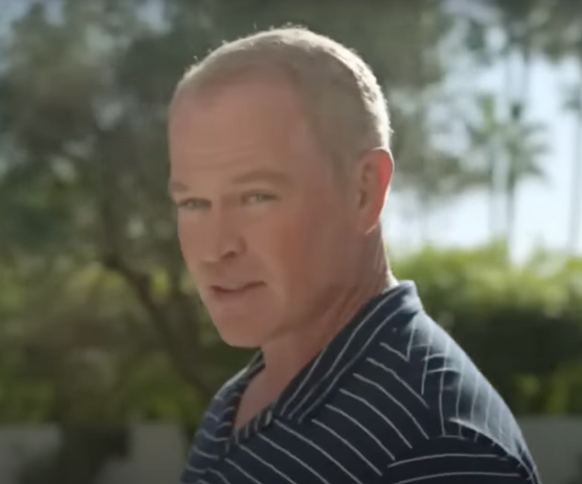 | 
"Other countries, they work, they stroll home, they stop by the cafe. They take August off. Off." | "Other countries, they work, they stroll to the market and buy locally grown food. Locally."
The use of "other countries" evokes feelings of American Exceptionalism, distinguishing the American way of life as superior to other non-American cultures. Cadillac's commercial frames European customs of leisure like going to a cafe or "strolling" home, as antithetical to the American ethos of hard work. Reduplication of "off" emphasizes the supposed absurdity of not working in August, further distinguishing America as superior to Europe. However, Ford's view of those "other countries" is much more positive, framing their ability to "stroll" to the market as an ideal rather than a problem. Highlighting others' access to locally grown food through the reduplication of "locally" points out a weakness in America, directly challenging Cadillac's nationalist attitude.

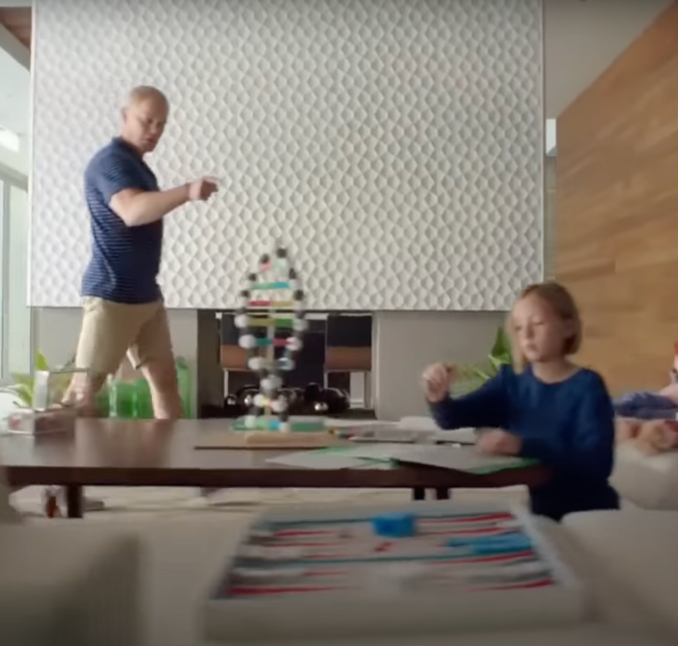 | 
"We're crazy, driven, hardworking believers." | "We're crazy entrepreneurs trying to make the world better."
Cadillac and Ford show what they think makes Americans special, agreeing that they are primarily "crazy." Cadillac sees Americans as "believers" with drive and who work hard, leaving out what they are working towards or what they believe in. With this line, McDonough points directly at his supposed young daughter as she does homework, suggesting that working hard is a skill best learned early in life. This characterization prioritizes the individual and their ability to improve their immediate circumstances. Ford suggests an alternative perspective, instead referring to Americans as "entrepreneurs" with the goal of improving the world. Unlike Cadillac, Ford's characterization prioritizes selfless actions that improve the circumstances of others while at the same time benefitting oneself.

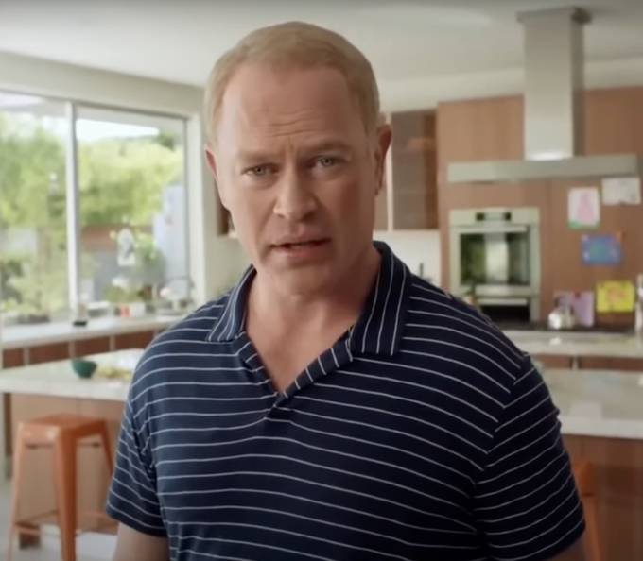 | 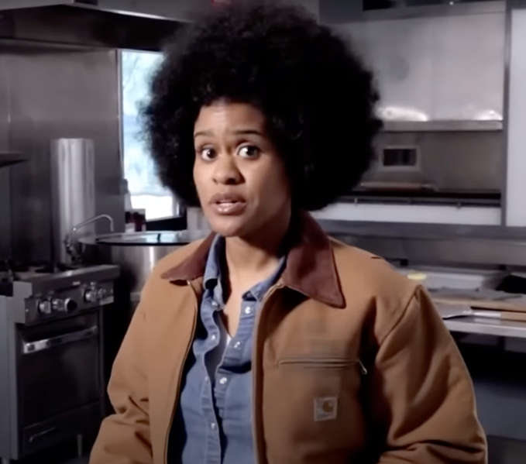
"We went [to the moon] and you know what we got? Bored. So we left." | "Me? I collect food scraps from restaurants and manure from zoos. Manure."
Cadillac cites the feat of landing on the moon as an example of Americans being "crazy, driven, hardworking believers." This project was carried out to demonstrate American superiority over other nations, investing in technological innovation for the purpose of flaunting their results. Saying "we" did it implies a unity between this 1960s attitude and how Americans (including the viewer) should perceive the goals of hard work. "Me?" focuses directly on an individual, Murray, a specific example of how an "entrepreneur trying to make the world better" can exercise their agency. The reduplication of "manure" not only matches the cadence of McDonough's line, but also emphasizes the potential for hardship throughout the process, attempting to realistically portray results from altruistic intentions.

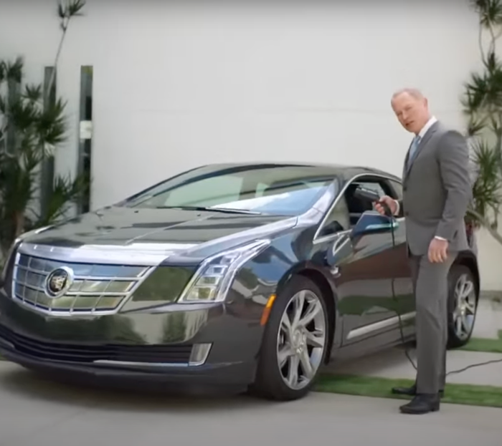 | 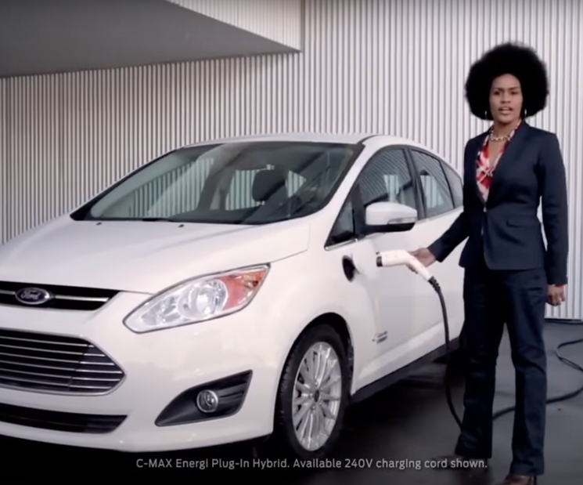
"It's pretty simple: you work hard, you create your own luck, and you gotta believe anything is possible." | "Look, it's pretty simple. You work hard, you believe that anything is possible, and you try to make the world better. You try."
The brands concisely explain the main takeaways from their ad. Both consider their path to success as "simple," only consisting of three vague steps, including "work hard" and "believe anything is possible." While Cadillac insists on the importance of "creating your own luck," Ford replaces this idea with "trying to make the world better." The concept of "creating your luck" implies an individual has total control over their chance of success and is therefore responsible for any setback or challenge they face. Ford does not propose this unrealistic idea and instead suggests that any attempt at altruism can make a difference. Regardless of the outcome, Ford repeats how it is only important that "you try." This outlook does not see the individual being responsible for success, but instead being responsible for selfless action.
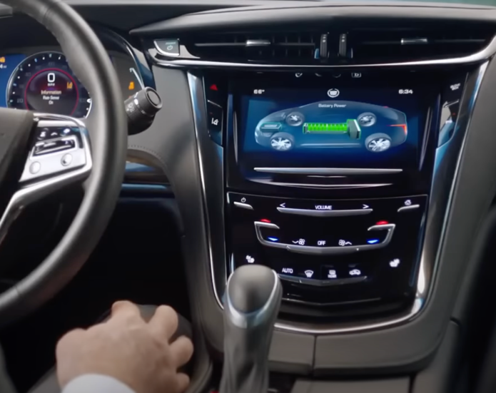 | 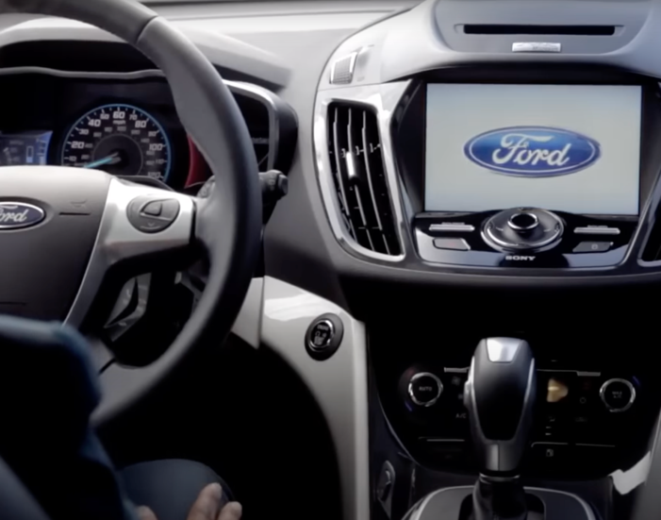
"As for all the stuff, that's the upside of only taking two weeks off in August." | "As for helping the city grow good green healthy vegetables, that's the upside of giving a damn."
Cadillac revisits the idea of Americans seeing the primary motivation for hard work as the potential for acquiring possessions. Having "all the stuff" is characterized as "the" upside rather than "an" upside to being "crazy, driven, hardworking believers." This use of a definite article implies only one upside: the ability to purchase things. The ad frames this agency as just a perk for the individual who works hard, rather than being a motivator for working hard. The concurrent visual of the car helps the viewer see the featured product as a potential reward for intentional action, such as working for two additional weeks in August.
Ford responds by insisting that one's mindset, "giving a damn," is more important than the actions one might take to do so. "The" (as opposed to "an") upside of wanting to improve the world seems to be the positive effect altruistic behavior has on others. Murray "giving a damn" manifested in "helping" Detroit grow more vegetables, but the action she took to do that was by creating dirt through composting. As a callback to the idea of her hard work being just "for dirt," the true motivation behind her work is revealed: improving society by helping others.
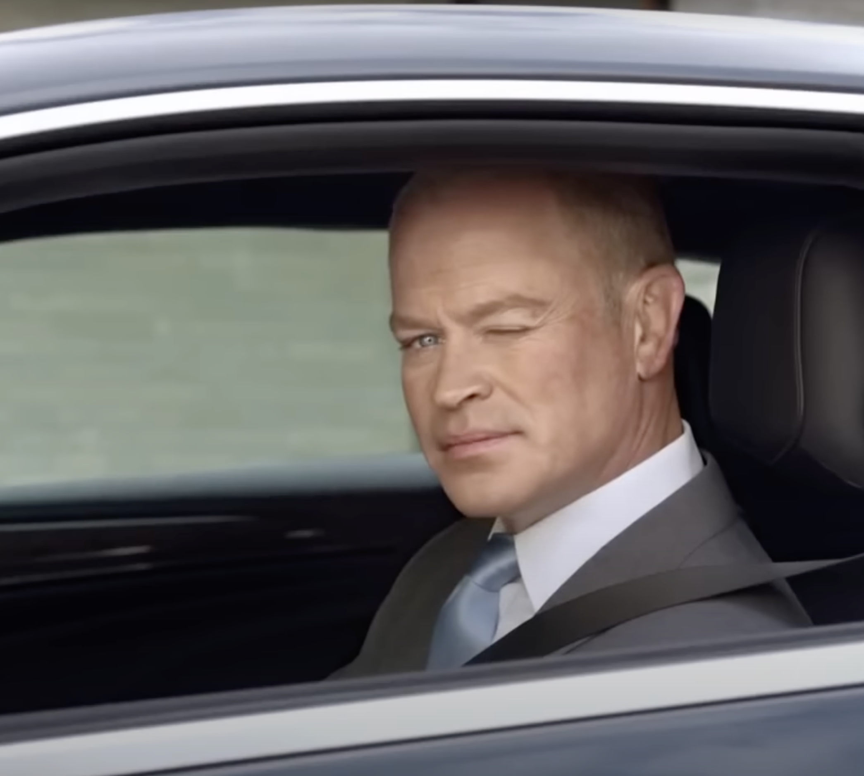 | 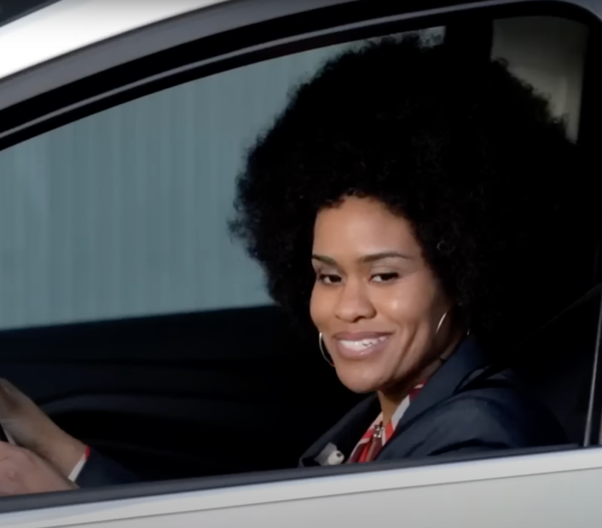
"N'est ce pas?" | "N'est ce pas?"
The tag question n'est ce pas is considered antiquated in French, and occasionally used in English to indicate a very formal register. Using an interrogative clause immediately after a declarative clause comprises speech acts of assertion and a request for confirmation from the listener. The rising tone used by McDonough signifies an expectation for the viewer to answer, encouraging engagement with the ideas presented in the commercial. Winking, a form of symbolically communicating a secret, subtly cues the viewer to agree. Murray, however, uses a flat tone, indicating a rhetorical question that reinforces her confidence in the statements. The context of the line, the fact that it is borrowed from the Cadillac ad, adds an assertive and combative undertone instead of indexing the same formal register.
Cadillac clearly uses this French phrase to associate these ideas with an upper-class lifestyle, drawing on the consistent American association of the French language with prestige and high social status. However, when analyzed alongside the earlier comments suggesting French customs like going to a cafe or having August off, these two characterizations of the French appear to contradict. The previously established superiority of America over the "other countries" is undermined by this pretentious attempt to evoke feelings of effortless elegance.

5. DISCUSSION
5.1 Elaborating on key findings
The semiotic choices made by Cadillac and Ford in these commercials suggest specific and distinct arguments around how American exceptionalism should be conceptualized in the current neoliberal context. The discourses in both commercials, however, still exemplify the following neoliberal Discourse:
Hard work as a means to improving one's circumstance defines the uniquely American conception of homo economicus
Cadillac's ad features a hardworking and wealthy man who explains how he was able to create his success. He engages the mindset that allowed other Americans to find success, believing in his inherent potential. He works hard, more so than non-Americans. As a result, he is then rewarded with the ability to construct a luxurious lifestyle by purchasing objects, such as a pool, house, suit, and a brand-new electric car. His hard work directly improved his life.
Ford uses the same composition and structure in their ad to directly challenge this proposition. They feature a female activist explaining how her selfless and caring attitude around helping others in her community led to substantial change. She contributed to the overall cause by working hard in the form of many small, tangible actions. When combined with others' hard work, many benefitted. Her altruistic actions that improved the lives of everyone in the community, including her, were a result of her mindset. Her hard work improved her life through improving life for all.

5.2 Placing key findings in context
While effective at communicating each brand's perspective on the correct homo economicus, the portrayal of these ideal figures as an expectation for and responsibility of the consumer fails to recognize any restrictions or barriers that are inherently out of their control. These brands oversimplify how neoliberalism realistically manifests by assuming all have equal access to the required resources in order to engage with these recommendations. For example, the idea that one can "create their own luck" implies an individual has an unattainable level of influence over their circumstance and the actions of others. Similarly, prioritizing "making the world better" assumes one has financial security and enough spare time to do so when an unregulated free market inherently creates inequities in access to these resources.
These brands used these commercials to take bold, conflicting stances on how the ideal American should thrive in a neoliberal society, they also live in that neoliberal society and seek to improve their circumstances. A brand's ultimate goal is profit, and encouraging consumption of their product through any means benefits the brand. Cadillac's decision to debut its commercial during a popular broadcast like the Olympics could be an intentional strategy to generate publicity by provoking controversy. Ford's ad was, first and foremost, a critique of Cadillac. The argument in the ad seemed to have nothing to do with selling a car. In fact, they did not reference the concept of consumption at all. Instead, they seemed to use combative advertising as a means to be memorable to viewers and possibly to become involved in the resulting publicity.
6. CONCLUSION
It is clear that advertisements inherently promote consumerism in a neoliberal context. Neoliberalism creates intense competition between producers for consumer attention, resulting in these creative and memorable advertisements. The distinct lack of government regulation is a crucial factor defining the American economy, an additional consideration in this analysis that is unfortunately beyond the scope of this paper. Companies advertise in non-American markets with the added consideration of navigating strict government oversight. Further research is needed to determine how the observed use of multimodal semiotic communication to promote consumerism through a neoliberal lens is influenced by such regulation. Identifying patterns in advertisement strategies across and within free markets with different levels of regulation, such as how a company might create a misleading advertisement without it falling into the category of false advertising, might be another way for the government to develop specific regulations that protect the consumer. The framework of neoliberalism relies on the interaction between a company and consumers, and studying discourse in advertising can reveal and counteract its weaknesses.

7. AI DISCLOSURE
This paper did not use AI for any component of the writing process.

8. REFERENCES
Attar, A. E. A. (2015). A multimodal analysis of car billboard advertisements: Audi/BMW rivalry. CDELT Occasional Papers in the Development of English Education, 60(2), 123–162. https://doi.org/10.21608/opde.2015.77303
Castro, J. C. L. de. (2015). The consumer as agent in neoliberalism SSRN Scholarly Paper 2859781. https://papers.ssrn.com/abstract=2859781
Ford’s response to Cadillac’s ELR ad. (n.d.). Retrieved December 12, 2023, from https://www.youtube.com/watch?v=24VerifhVJk
Ganti, T. (2014). Neoliberalism. Annual Review of Anthropology, 43, 89–104. https://www.jstor.org/stable/43049564
Gide, C. (1898). Has co-operation introduced a new principle into economics? The Economic Journal, 8(32), 490–511. https://doi.org/10.2307/2957091
Golsorkhi, D. Seidl, E. Vaara, & L. Rouleau (Eds.). (2015). CDA as methodology in SAP practice. In Cambridge Handbook of Strategy as Practice (2nd ed., pp. 491–505). Cambridge University Press. https://doi.org/10.1017/CBO9781139681032.029
Jean, S. (2011). Brand parody: A communication strategy to attack a competitor. Journal of Consumer Marketing, 28(1), 19–26. https://doi.org/10.1108/07363761111101912
Scott, C. V. (2018). Neoliberal patriotism. In C. V. Scott (Ed.), Neoliberalism and U.S. Foreign Policy: From Carter to Trump (pp. 171–209). Springer International Publishing. https://doi.org/10.1007/978-3-319-71383-0_5
Symes, S. (2014, March 7). Cadillac ELR commercial stirs up controversy. Insider Car News. https://www.insidercarnews.com/cadillac-elr-commercial-stirs-up-controversy/
Trending: N’est-ce pas. (n.d.). Retrieved December 12, 2023, from https://www.merriam-webster.com/news-trend-watch/n%27est-ce-pas-2014-04-04

8. APPENDIX
Full transcript of Cadillac's Poolside | Full transcript of Ford's Upside
Why do we work so hard? | Why do I work so hard?
For what? | For what?
For this? | For this?
For stuff? | For dirt?
Other countries, they work, they stroll home, they stop by the cafe, they take August off. | Other countries, they work, they stroll to the market and buy locally grown food.
Off. | Locally.
Why aren't you like that?
Why aren't we like that? | Why aren't we like that?
 | Well more and more of us are like that.
Because we're crazy, driven, hardworking believers, that's why. | Because we're crazy entrepreneurs trying to make the world better.
Those other countries think we're nuts. | Some people might think we're nuts.
Whatever. | Whatever
Were the Wright Brothers insane? Bill Gates? Les Paul? Ali? | Me? I collect food scraps from restaurants. Manure from zoos.
Were we nuts when we pointed to the moon?
That's right.
We went up there and you know what?
We got bored.
So we left.
Got a car up there, left the keys in it. | Manure.
Do you know why? | Do you know why?
Cause we're the only ones going back up there, that's why. | To keep this stuff out of landfills and use it to make good rich dirt, that's why.
But I digress | Yeah.
It's pretty simple: You work hard, you create your own luck, and you gotta believe anything is possible | Look, it's pretty simple: You work hard, you believe anything is possible, and you try to make the world better.
 | You try.
As for all the stuff, that's the upside of only taking two weeks off in August. | As for helping the city grow good green healthy vegetables, that's the upside of giving a damn.
N'est ce pas? | N'est ce pas?

Golsorkhi et al. (2015) define "text" as any mode or combination of modes of semiotic communication. This includes the traditional linguistic modes, speech and writing, and visual or auditory modes. This framework can therefore be adapted for a multimodal discourse analysis.
While not directly in the scope of these research questions and maybe not even intentional, a close analysis of this shot suggests that McDonough is wearing a wool suit. Wool is the most accessible and cheapest material for a suit, a choice that does not align with how he flaunts his wealth through his other unnecessarily luxurious purchases. For example, for the purpose of transportation only, one does not buy a Cadillac, indicating he usually prioritizes status over comfort or price. Furthermore, a wool suit is very insulating. In what is assumed to be a tropical environment (given the palm trees in the background of the first shot), it would be both ridiculously uncomfortable and inappropriate to wear a suit made of wool. A more breathable and appropriate fabric for wear in hot weather would be linen, which is considerably more expensive. While wool does somewhat function as a material for a suit in warm weather, a more luxurious (and fully functional) choice would be linen, as he clearly does not spare any other expense to appear prestigious. However, his tie is in a Windsor knot, a more difficult and therefore more formal knot, which is consistent with him valuing appearances and status over comfort or ease.
The timeline of the number of searches for this phrase in the online Merriam-Webster Dictionary shows a notable but narrow spike at the beginning of 2014. N’est-ce Pas. (n.d.) ascribes the sudden dramatic increase in curiosity about the relatively outdated phrase to use in this Cadillac commercial. While the intent was probably to sound formal and prestigious, the use ended up being obscure to the point of alienating as the audience clearly didn't know what he was trying to say.

