Vowel Length in L1, Bilingual, and L2 Spanish: A Contrastive Analysis

Cole Stofflet
Amber Lynch
University of Pittsburgh
LING 2578: Phonetics and Phonemics
Dr. Amanda Huensch
December 9, 2024

Vowel Length in L1, Bilingual, and L2 Spanish
1. Introduction
Spanish is one of the most widely spoken languages in the world, with a speaker population in the hundreds of millions (Eberhard et al., 2024; Martínez-Celdrán et al., 2003). As a result, there is no shortage of Spanish language students, which requires the continuous development of pedagogical strategies. Vowels represent one of the most salient differences between English and Spanish. The vowel inventory of English is relatively large in comparison with Spanish, and it has rough equivalents of each of Spanish’s phonemic vowels. Because of this, L1 English speakers may not struggle to produce vowels of similar quality to those found in Spanish. However, the transfer of prosodic features of L1 English to L2 Spanish, such as reduction of unstressed vowels, may result in speech that is significantly marked as non-native and is therefore of great pedagogical interest (e.g., Martínez-Celdrán and Elvira-García 2019; Cobb and Simonet 2015; Romanelli et al., 2016).
The following study examines the speech of three Spanish-speaking individuals. One is an L2 Spanish speaker (L1 English), one acquired English and Spanish concurrently from early childhood, and one is an L1 speaker of Peninsular Spanish. We begin with a review of the Spanish sound inventory, with a particular focus on vowel phonemes and their variants, as well as a more detailed review of prosodic differences between the two languages. Having established background, we then proceed to our methods and analysis. The participants read a short story in a sound-controlled environment and vowel tokens were extracted for analysis in Praat. The tokens’ durations were measured to test the degree of transfer of prosodic features from English to Spanish. Two one-way ANOVAs were conducted to analyze the overall differences in vowel duration between the participants and to identify any durational patterns intrinsic to vowel height.
2. Literature Review
2.1 Consonants
Due to its large speaker population and wide geographic reach, Spanish exhibits considerable dialectal variation, mostly in the realization of consonants. As this study is primarily concerned with vowels, we will not cover consonantal variation extensively.
Table (1) below shows the phoneme inventory of educated, middle-aged Castilian Spanish speakers (i.e., Spanish as it is spoken in Central Spain), courtesy of Martínez-Celdrán et al., (2003).
 | Bilabial | Labiodental | Dental | Alveolar | Palatal | Velar
Plosive | p b |  | t d |  |  | k g
Affricate |  |  |  |  | ͡tʃ ͡ɟʝ
Nasal | m |  |  | n | ɳ
Tap or flap |  |  |  | ɾ
Trill |  |  |  | r
Fricative |  | f | θ | s |  | x
Lateral approximant |  |  |  | l | ʎ
Table (1). Phonemic consonants of formal Spanish as spoken in Castile by educated, middle-class speakers (Martínez-Celdrán et al., 2003).
/θ/ and /ʎ/, it should be noted, are not present in all Spanish varieties. In most of the Spanish-speaking world outside of Castile, [θ] does not occur but is rather realized as [s] and grouped under the same phonemic category as /s/. Similarly, outside of Castile, /ʎ/ is frequently realized as [͡ɟʝ] or [ʝ] and grouped under the same phoneme as /͡ɟʝ/ (Martínez-Celdrán et al., 2003).

2.2 Vowels
The vowel inventory of Spanish is a typical five-way split, /a i u e o/ (e.g., Hualde 2005; Martínez-Celdrán et al., 2003; Bradlow 1995; Martínez-Celdrán and Elvira-García 2019). Although it is relatively small in comparison to that of English (e.g., Bradlow 1995), it still exhibits a wide array of acoustic and articulatory distinctions: it includes front, central, and back vowels; high, mid, and low vowels; vowels produced with a more closed or open jaw; and both rounded and non-rounded vowels.
 | Front | Central | Back
High | i |  | u | Closed
Mid | e |  | o | Open
Low |  | a |  | Open
 | Non-round |  | Round
Table (2). Phonemic vowels of Spanish (Hualde 2005).
2.2.1 Environmental Variation and Diphthongization
Navarro Tomás (1918), cited in Martínez-Celdrán and Elvira-García (2019), notes several environment-conditioned changes in Castilian Spanish. Vowels become more open in closed syllables, when in contact with [r], or when followed by [x]. /e/ does not undergo this change when preceding /m n s d θ/. In /ei/ and /oi/, however, the jaw opens a little wider for both /e/ and /o/. Lastly, /a/ may be fronted when adjacent to palatal sounds and more back when preceding back sounds, like /x o u/, or when in a syllable closed by /l/.
Unlike in English, Spanish vowels are not subject to reduction processes in unstressed syllables (e.g., Cobb and Simonet 2015; Hualde 2005). There is also no phonemic nasality distinction in Spanish, although vowels may become nasal when preceding nasal consonants and must be nasalized between them (Martínez-Celdrán and Elvira-García 2019). Likewise, Spanish has no phonemic length distinction, although the type of utterance, as well as some prosodic elements, do appear to impact duration. These include being in the prosodic nucleus, especially of a statement rather than a question (Fernández Planas and Martínez-Celdrán, 2003) and stress, which generally results in slightly longer syllables (Hualde 2005; Martínez-Celdrán and Elvira-García 2019). This contrasts with English, in which unstressed vowels undergo significant reduction, both by way of centralization and comparative shortening (Hualde 2005; Martínez-Celdrán and Elvira-García 2019; Cobb and Simonet 2015).
When two vowel phonemes are adjacent in an utterance, one of the vowels may become non-syllabic. Usually, when an unstressed high vocoid (/i u/) is adjacent to a nonhigh vocoid (/a e o/), it is the high vocoid that becomes non-syllabic ([i̯ u̯]) (Martínez-Celdrán et al., 2003; Hualde 2005). If, however, the high vocoid is stressed, then it usually remains syllabic and constitutes the nucleus of its own syllable. Sequences of two high vocoids usually lead to the first being realized as a glide rather than the second (Hualde 2005).
Unstressed high vocoid + nonhigh vocoid | Nonhigh vocoid + unstressed high vocoid | High vocoid + high vocoid | Stressed high vocoid + nonhigh vocoid
cuadro | aire | viuda | tía
/kuádɾo/ | /áiɾe/ | /biúda/ | /tía/
[ku̯áðɾo] | [ái̯ɾe] | [bi̯úða] | [tí.a]
‘square, painting’ | ‘air’ | ‘widow’ | ‘aunt, relative’
Table (3). Examples of vocoid sequences in Spanish.
There are some ambiguities. For one, there are lexical exceptions to the gliding rule (e.g., dueto [du.éto] ‘duet,’ reiré [re.iɾé] ‘I will laugh’). However, these are subject to significant dialectal and idiolectal variation (Hualde 2005). Another important factor is the behavior of sequential nonhigh vocoids. Hualde (2005) says that when they occur in sequence, they are syllabified as hiatus (e.g., poeta [po.éta] ‘poet’), but in at least some dialects, one of these segments may become non-syllabic in certain circumstances (e.g., Castilian poeta [po̯éta] ‘poet’) (Martínez-Celdrán et al., 2003). Lastly, while all the diphthongization and vowel hiatus examples presented thus far have been within single words, Spanish’s gliding rules can apply across the word boundary within an utterance (e.g., norte hubo /nóɾte úbo/ [nóɾte̯úβo] ‘north there was’) (Martínez-Celdrán et al., 2003).
2.3 English and Spanish Rhythm
Much has been made in some of the literature (e.g., Pike, 1945, as cited in Pointon, 1980) over the distinction between stress-timed languages and syllable-timed languages. Stress-timed languages are those in which the unstressed syllables of an utterance are shortened such that the amount of time between any two stressed syllables is roughly equal; English, with its frequent reduction (i.e., centralization and shortening) of unstressed vowels, is often given as an example. In contrast, in syllable-timed languages, like Spanish, each syllable is roughly the same duration, regardless of whether it is stressed or unstressed. One argument for distinguishing stress- and syllable-timing is the different poetic traditions of such languages. The English sonnet, for instance, is written in iambic pentameter, where stress is a central function of well-formedness (Hualde 2005). An iamb is composed of one unstressed syllable followed by a stressed one; in pentameter, five metrical feet comprise a line. For example, the first line of Shakespeare’s Sonnet 130: “My místress’ éyes are nóthing líke the sún,” (stress marks were added for clarity) (Shakespeare 1609). In contrast, the lines of Spanish sonetos must be made of endecasílabos, which consist of eleven syllables, without regard for stress (Hualde 2005). For example, the first line of De Góngora’s Soneto 166: “Miéntras por competír con tú cabéllo,” (stress marks were added for clarity) (De Góngora 1582).
Despite these supposed distinctions, the reality is more complex. As Hualde (2005) reminds us, some segments take inherently longer to pronounce than others (e.g., [ɾ], which is shorter than [r]); low vowels have inherently greater duration than high ones; and syllable duration may be impacted by position relative to the end of the utterance as well as the type of utterance (Fernández Planas and Martínez-Celdrán 2003). Furthermore, duration correlates with stress in both English and Spanish, meaning that, in both languages, stressed syllables are longer than unstressed ones (Hualde 2005).
Also contributing to the perception of different timing systems is the greater frequency in English of consonant clusters, which naturally take longer to produce, and the fact that the durational differences between English stressed and unstressed syllables are so great that it is much more salient to the English sound system, as compared with the comparatively modest durational distinctions between stressed and unstressed syllables in Spanish (Hualde 2005).
3. Methodology
Because of the influence of vowel production on whether a language's rhythm is realized as more stress-timed or syllable-timed, measuring the variance in the duration of a speaker’s vowels can reveal whether and to what degree vowels are shortened or lengthened. In taking this approach to compare speakers of Spanish of varying proficiencies, we propose the following research question to guide the analysis:
RQ: Will vowels produced by a non-native Spanish speaker vary in length more than vowels produced by a native speaker?
As shown in Cobb and Simonet (2015) and Romanelli et al. (2016), L1 English learners of Spanish apply English prosodic features such as vowel reduction and weakening in unstressed syllables in Spanish speech. However, because vowel length can correlate with features of the vowel itself (e.g., height, openness) independently of its stress (Hualde 2005), we propose two hypotheses in predicting the outcomes of the analysis:
H1: The duration of vowels produced by the non-native Spanish speaker will vary more overall in comparison to those produced by the native speakers.
H2: The duration of high vowels (/i/ and /u/) will be shorter than nonhigh vowels (/e/, /a/ and /o/) across both speakers, regardless of L1.
To test this research question, speakers of Spanish of varying levels of proficiency were informally recruited from the Linguistics Department at the University of Pittsburgh, and basic demographic information was self-reported as appropriate, such as level of proficiency and/or country of origin. Six students participated in total: four L1 Spanish speakers, one bilingual speaker who acquired both languages concurrently at a young age, and one L1 English speaker at a high-intermediate level of Spanish proficiency. Each speaker read the stimulus material (the short story “El Viento Norte” (Martínez-Celdrán et al., 2003), which can be found in the Appendix) in a soundproof room into a professional microphone. After developing the segmentation guidelines, both authors segmented an audio file in Praat and conducted a correlative inter-rater reliability test to confirm the guidelines’ effectiveness. Figure (1) below is a plot of the boundary placement agreement:
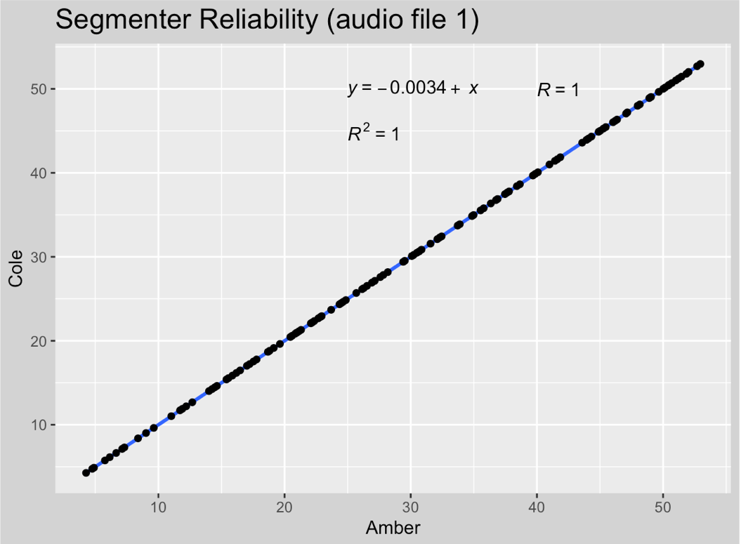
Figure (1). Correlation of author's segmentation of one audio file.
As described in Section (2), Spanish gliding rules may cause phonemic vowels to become non-syllabic in various phonetic environments. These sequences cannot be cleanly divided into their constituent segments and it is therefore very difficult to measure their duration. For these reasons, this analysis only considered monophthongal vowels, defined as vowels that do not precede or follow another vowel or semivowel ([i̯] or [u̯]).
The location of the boundaries was compared using a Praat script. Because of the high correlation seen in the inter-rater reliability test, the average was taken between the vowel durations observed by both authors to represent the duration of each vowel token in the subsequent analysis.

4. Results
Figure (2) below indicates the durations of all the vowels in the sample as spoken by each speaker. S1 is the L1 Spanish speaker, S2 is the Spanish-English bilingual, and S3 is the L2 Spanish speaker.
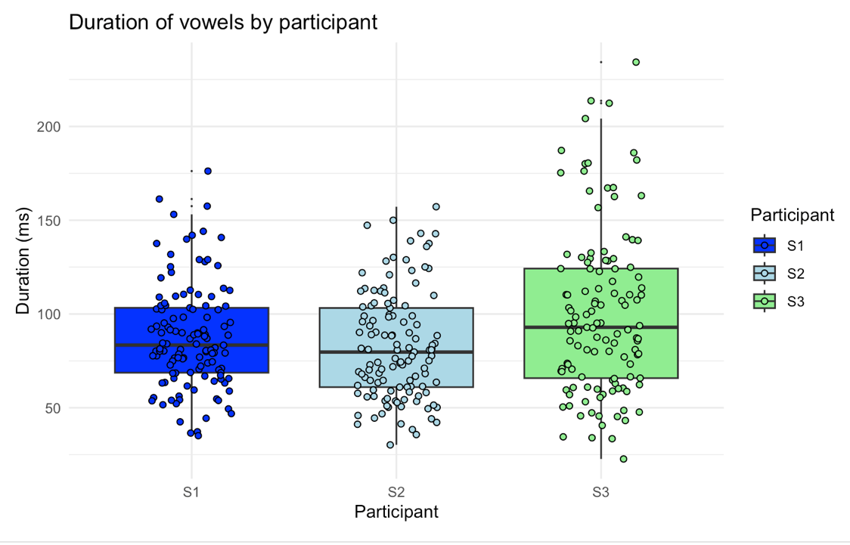
Figure (2). Distribution of vowel durations by participant
These values are also summarized below in Table (4):
Participant | Mean | Standard Deviation | Median | Minimum | Maximum
S1 (L1 Spanish) | 87.76446 | 27.87652 | 83.4 | 35.1 | 176.2
S2 (Bilingual) | 82.88347 | 28.69326 | 79.7 | 30.2 | 157.2
S3 (L2 Spanish) | 100.06446 | 43.86428 | 92.9 | 22.7 | 234.3
Table (4). Summary statistics of vowel duration distributions.
The three distributions appear to be normally distributed with similar standard deviations. A one-way ANOVA was conducted to compare variance in duration among the three participants, revealing a significant effect [F(2, 360) = 8.073, p > .0001, ηp² = 0.04]. Tukey HSD post hoc comparisons indicated reliable differences between the L2 Spanish speaker and the L1 Spanish speaker, as well as between the L2 Spanish speaker and the bilingual speaker. The analysis was conducted at a 95% confidence level. The results can be found below in Table (5).
Participants Compared | Difference | Lower | Upper | P-adjusted
S2-S1 | -4.880992 | -15.251829 | 5.489845 | 0.6099632
S3-S1 | 12.30000 | 1.929163 | 22.670837 | 0.0152406*
S3-S2 | 17.180992 | 6.810155 | 27.551829 | 0.0003386*
Table (5). Confidence intervals of mean difference between participant vowel durations

Overall, these statistical tests show the L2 Spanish speaker produced vowels that varied more reliably in length than those produced by the bilingual speaker or the L1 Spanish speaker, confirming Hypothesis (1). In order to test Hypothesis (2), the vowels were further coded by the subcategories High and Nonhigh. Figure (4) reflects this further subdivision within each participant.
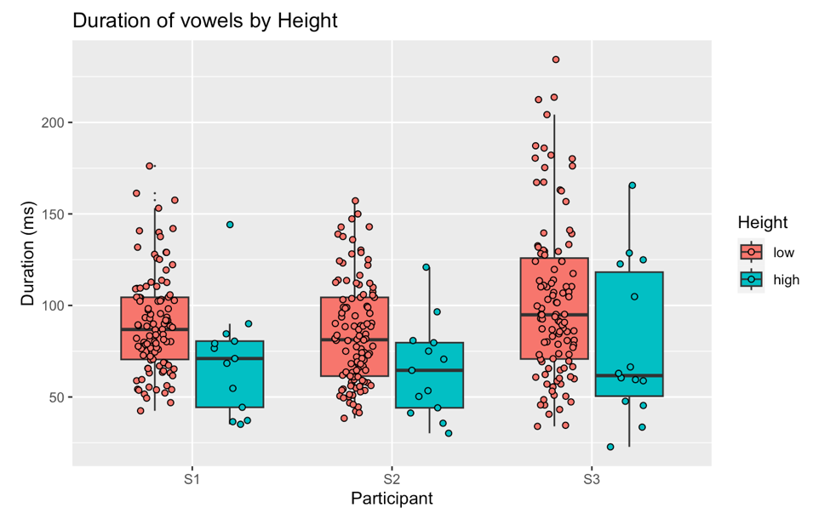
Figure (4). Distribution of vowel duration by participant and vowel height.
Another one-way ANOVA was conducted to investigate the potential effect of vowel height, yielding a significant effect [F(4, 358) = 7.988, p > 0.0001, ηp² = 0.08]. Post hoc pairwise comparisons revealed some reliable differences, shown in Table (6) below.
Phonemes Compared | Difference | Lower | Upper | P-adjusted
i-a | -26.156696 | -48.391427 | -3.9211966 | 0.0119221*
i-o | 11.813124 | -9.979184 | 33.605433 | 0.5721160
i-e | -8.1173353 | -30.198056 | 13.963349 | 0.8516680
u-a | -39.782511 | -62.957562 | -16.607460 | 0.0000354*
u-o | -25.438939 | -48.189861 | -2.688016 | 0.0196773*
u-e | -21.743168 | -44770482 | 1.284146 | 0.0745592
e-a | -18.039343 | -31.102463 | -4.976223 | 0.0016728*
o-e | 3.695771 | -8.599211 | 15.990753 | 0.9230772
o-a | -14.343572 | -26.913075 | -1.774070 | 0.0161974*
i-u | -13.625815 | -42.849013 | 15.597384 | 0.7047085
Table (6). Pairwise comparisons between vowel phonemes across all speakers
With this method, the durations of the high vowel /u/ were found to be reliably different from /a/ and /e/ across the L1, bilingual, and L2 speakers. However, reliable differences were also found between durations of the nonhigh vowel /a/ and the other nonhigh vowels /e/ and /o/. Because only half of the pairwise comparisons produced reliable differences and reliable differences occurred in comparing nonhigh vowels with each other, Hypothesis (2) cannot be confirmed with this data.

5. Implications and Limitations
The results presented above show that the transfer of English vowel shortening in unstressed syllables is to be expected in L2 Spanish speakers. Contrary to what is suggested in the literature, however, it appears that vowel height may not consistently impact duration.
With that in mind, the present study had significant limitations, which should be considered. For one, the sample size may not have been representative of the populations under investigation. All participants were highly educated (possessing or pursuing graduate-level education) and are, as noted in Section (3), students at the University of Pittsburgh’s Department of Linguistics. The subject of their studies is particularly relevant, given their background knowledge of linguistics and, potentially, phonetics, which may have influenced their performance during the reading task. Of even greater importance is that the L1 speaker consulted for this study was familiar with the stimulus. The potential for bias in the results should not be discounted.
5.1 Future Research
This analysis can be expanded upon in future studies in several ways, the most straightforward of which would be to examine the influence of different phonetic environments on the duration of vowels within the three speakers. As shown in Hualde (2005), vowel duration can also be impacted by stress, the presence of a rhotic sound in the immediate environment, and syllable structure (i.e., whether a vowel is part of a closed or open syllable). A regression analysis comparing the influence of these different linguistic factors would offer insight into how much of the variation in duration might be intrinsic to the sounds themselves rather than a result of L1 transfer.
Additionally, while dialectal variation across the Spanish-speaking world is well understood with regard to consonantal variation, little attention has been given to comparing features of vowel production across dialects (Whitley 2002). Because of this and since data from only one L1 Spanish participant was analyzed, there is a possible interaction between the level of variation and dialect that was not accounted for in the present study. Future research into this potentiality may help to establish a more reliable baseline to measure prosodic and other forms of transfer from an L1 to L2 (or at least from L1 English to L2 Spanish).
Finally, register was not accounted for in the present study. Reading tasks such as the one used here tend to elicit careful, more formal, and, in some cases, over-articulated speech. As such, it may be more accurate to say that the results in Section (4) describe differences in reading pronunciations than in the participants’ speech as a whole. Future researchers may wish to consider spontaneous speech to test the impact, if any, of register on proportional vowel durations.
6. Reflection
Through the process of writing this paper, we gained a lot of practical experience on how to conduct phonetics experience. Firstly, we used the Language Media Center recording studio, learned how to resolve technical problems (e.g., how to set the correct audio input and how to make sure the participants are using the correct microphone), and to use basic functions of Audacity. Amber learned how to customize the aesthetic functions of data visualizations in ggplot in order to create clearer and more visually pleasing box plots for the presentation and the paper. Cole learned that the variation of duration of his vowel production in Spanish is very close to that of an L1 speaker (acknowledging that this is a breach of participant anonymity, but we hope this indiscretion is acceptable on this occasion).
7. Appendix
6.1 El Viento Norte
El viento norte y el sol porfiaban sobre cuál de ellos era el más fuerte, cuando acertó a pasar un viajero envuelto en ancha capa. Convinieron en que quien antes lograra obligar al viajero a quitarse la capa sería considerado más poderoso. El viento norte sopló con gran furia, pero cuanto más soplaba, más se arrebujaba en su capa el viajero; por fin el viento norte abandonó la empresa. Entonces brilló el sol con ardor, e inmediatamente se despojó de su capa el viajero; por lo que el viento norte hubo de reconocer la superioridad del sol.
6.2 Segmentation Protocol
- Only segment monophthongal vowels (underlined above)
- Diphthongs ignored:
  - When formed by two consecutive vowels
  - When formed by a vowel and a glide [i̯] or [u̯]
  - When crossing word boundaries
  - When part of the suffix -ado
  - When straddling the silent grapheme “h”
- Adjacent vowels are segmented if broken up by written punctuation (. or ,)
- Vowel sound begins after any aspiration, at the beginning of periodicity in the waveform

8. Works Cited
Bradlow, A. R. (1995). A comparative acoustic study of English and Spanish vowels. The Journal of the Acoustical Society of America, 97(3), 1916–1924. https://doi.org/10.1121/1.412064
Cobb, K., & Simonet, M. (2015). Adult Second Language Learning of Spanish Vowels. Hispania, 98(1), 47–60. https://doi.org/10.1353/hpn.2015.0026
Colina, S., & Martínez-Gil, F. (Eds.). (2020). The Routledge handbook of Spanish phonology. Routledge, Taylor & Francis Group.
Čubrović, B. (2019). Duration as a Phonetic Cue in Native and Non-Native American English. ELOPE: English Language Overseas Perspectives and Enquiries, 16(1), 15–28. https://doi.org/10.4312/elope.16.1.15-28
De Góngora, L. (1582). Soneto CLXVI. Retrieved 2024-12-08 from https://www.espoesia.com/poesia/luis-de-gongora-2/mientras-por-competir-con-tu-cabello/
De Manrique, A. M. B., & Signorini, A. (1983). Segmental duration and rhythm in Spanish. Journal of Phonetics, 11(2), 117–128. https://doi.org/10.1016/S0095-4470(19)30810-1
Eberhard, D. M., Fennig, C. D., & Simons, G. F. (Eds.). (2024). Spanish | Ethnologue free. Ethnologue. https://www.ethnologue.com/language/spa/
Fernández Planas, A. M., & Martínez-Celdrán, E. (2003). El tono fundamental y la duración: dos aspectos de la taxonomía prosódica en dos modalidades de habla (enunciativa e interrogativa) del español. Estudios de Fonética Experimental, 12, 165-200. https://revistes.ub.edu/index.php/experimentalphonetics/article/view/44460
Haro, A. H. de, & Hajek, J. (2022). Eastern Andalusian Spanish. Journal of the International Phonetic Association, 52(1), 135–156. https://doi.org/10.1017/S0025100320000146
Hualde, J. I. (Ed.). (2009). The sounds of Spanish (Repr). Cambridge University Press.
Hualde, J. I., Olarrea, A., & O’Rourke, E. (Eds.). (2012). The handbook of Hispanic linguistics. Wiley-Blackwell.
Martínez-Celdrán, E., & Elvira-García, W. (2019). Description of Spanish vowels and guidelines for teaching them. In Key Issues in the Teaching of Spanish Pronunciation. Routledge.
Martínez-Celdrán E., Fernández Planas, A. Ma., & Carrera-Sabaté, J. (2003). Castilian Spanish. Journal of the International Phonetic Association, 33(2), 255–259. https://doi.org/10.1017/S0025100303001373
McBride, K. (2015). Which Features of Spanish Learners’ Pronunciation Most Impact Listener Evaluations? Hispania, 98(1), 14–30. https://doi.org/10.1353/hpn.2015.0001
McCandless, A. (n.d.). Acoustic analysis of L1 and L2 Spanish vowels.
Pike, K. L. (1945). The Intonation of American English. University of Michigan Press.
Pointon, G. E. (1980). Is Spanish really syllable-timed? Journal of Phonetics, 8(3), 293–304. https://doi.org/10.1016/S0095-4470(19)31479-2
Resnick, M. C., & Hammond, R. M. (1975). The status of quality and length of Spanish vowels. Linguistics, 13(156). https://doi.org/10.1515/ling.1975.13.156.79
Romanelli, S., Menegotto, A., & Smyth, R. (2018). Stress-Induced Acoustic Variation in L2 and L1 Spanish Vowels. Phonetica, 75(3), 190–218. https://doi.org/10.1159/000484611
Shea, C. (2019). Dominance, proficiency, and Spanish heritage speakers’ production of English and Spanish vowels. Studies in Second Language Acquisition, 41(1), 123–149. https://doi.org/10.1017/S0272263117000328
Stevens, J. J. (2011). Vowel duration in second language Spanish vowels: Study abroad versus at-home learners. Journal of Second Language Acquisition and Teaching, 18(0), Article 0.
Shakespeare, W. (1609). Sonnet CXXX. In Shakespeare's Sonnets (2018). Minneapolis: First Avenue Editions.
Whitley, M. S. (2002). Spanish-English contrasts: A course in Spanish linguistics (2nd ed). Georgetown University Press.

While all four native speakers recorded speech data, for the scope of this assignment only one speaker's recordings were analyzed in detail (along with the bilingual speaker and L1 English speaker). As these speakers are from different regions (Spain vs Latin America), this analysis has the potential to be expanded to include a cross-dialectal comparison in the future.
This definition also applied to the suffix -ado, which is realized as the diphthong [ao] as a result of /d/ weakening in some dialects (including that of our native-speaker participant).
Rows with an asterisk (*) indicate a reliable difference at the p < .05 level
For this analysis, Low vowels include the nonhigh vowels /a e o/, and High vowels include/i u/
Shaded cells represent a comparison between a high vowel and non-high vowel.
The participants were provided with an unannotated copy of the “El Viento Norte” text.

